**Nama : Muhamad Yazid Imani**

**Kelas : INF – A2**

**NIM : J0303211068**

**2.) Buatlah matriks Adjacency, tentukan jumlah edge dan vertex dari Graph berikut ini !**

Jawab :

1. Jumlah Edge : 6

Jumlah vertex : 6

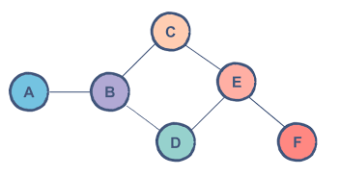

|  |  |  |  |  |  |  |
| --- | --- | --- | --- | --- | --- | --- |
|  | A | B | C | D | E | F |
| A | 0 | 1 | 0 | 0 | 0 | 0 |
| B | 1 | 0 | 1 | 1 | 1 | 0 |
| C | 0 | 1 | 0 | 0 | 1 | 0 |
| D | 0 | 1 | 0 | 0 | 1 | 0 |
| E | 0 | 0 | 1 | 1 | 0 | 1 |
| F | 0 | 0 | 0 | 0 | 1 | 0 |

1. Jumlah Edge : 21

Jumlah vertex : 9

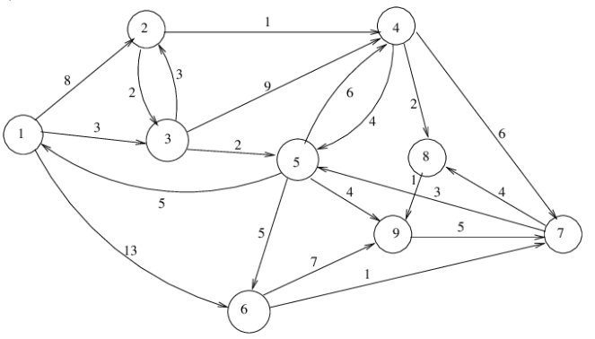

|  |  |  |  |  |  |  |  |  |  |
| --- | --- | --- | --- | --- | --- | --- | --- | --- | --- |
|  | 1 | 2 | 3 | 4 | 5 | 6 | 7 | 8 | 9 |
| 1 | 0 | 8 | 3 | 0 | 0 | 13 | 0 | 0 | 0 |
| 2 | 0 | 0 | 2 | 1 | 0 | 0 | 0 | 0 | 0 |
| 3 | 0 | 3 | 0 | 9 | 2 | 0 | 0 | 0 | 0 |
| 4 | 0 | 0 | 0 | 0 | 4 | 0 | 6 | 2 | 0 |
| 5 | 5 | 0 | 0 | 6 | 0 | 5 | 0 | 0 | 4 |
| 6 | 0 | 0 | 0 | 0 | 0 | 0 | 1 | 0 | 7 |
| 7 | 0 | 0 | 0 | 0 | 3 | 0 | 0 | 4 | 0 |
| 8 | 0 | 0 | 0 | 0 | 0 | 0 | 0 | 0 | 1 |
| 9 | 0 | 0 | 0 | 0 | 0 | 0 | 5 | 0 | 0 |